2022/9/13

1. 吸收光谱

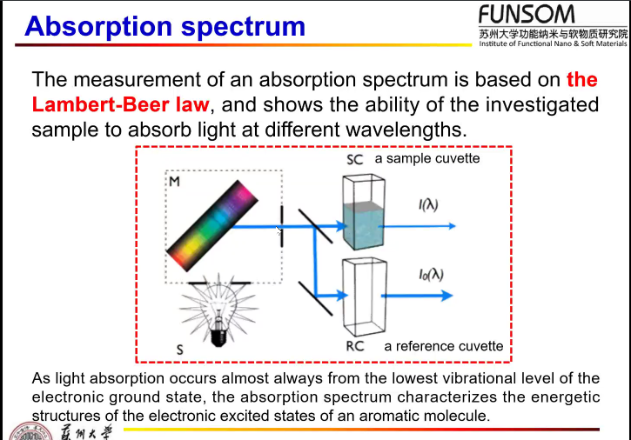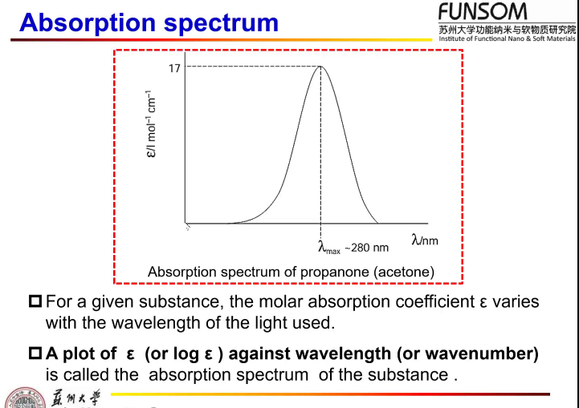

Vibrational fine structure 精细结构 may be showed by rigid hydrocarbons in nonpolar solvents要求：稀溶液，刚性溶剂

Because the polar solvents will influence the electron distribution of the solute.

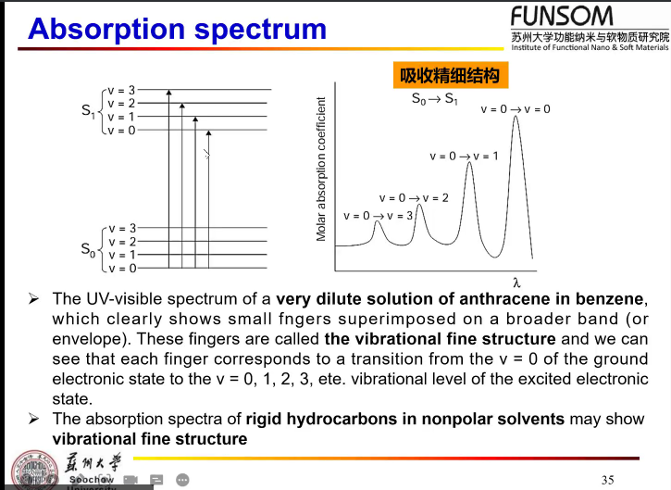

A broad and featureless absorption spectrum due to the very large number of vibrational levels in organic molecules and to blurring of any fine structure due to interaction between organic molecules and solvent molecules.

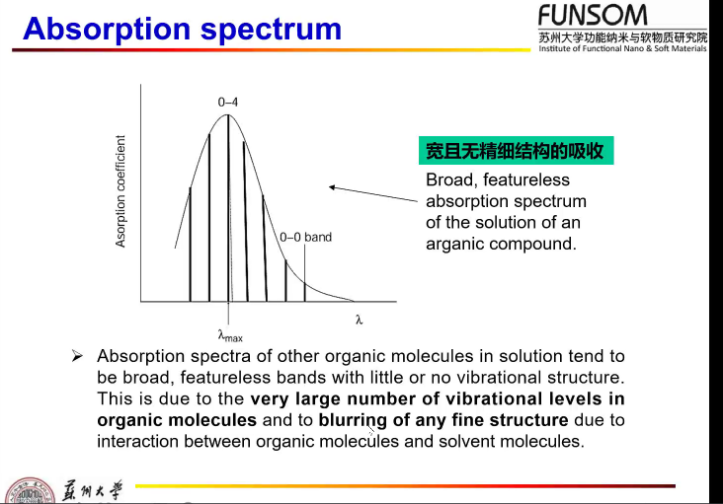

2. Deactivation electronically-excited state

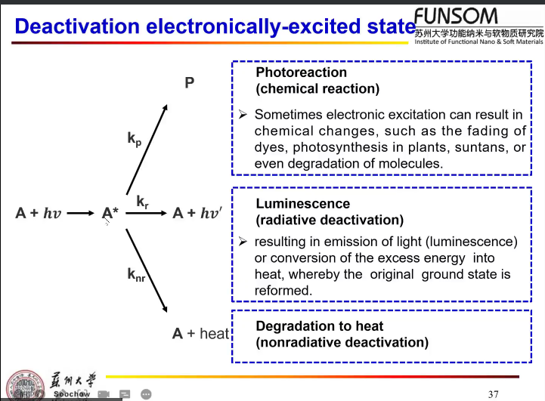

3. 期中考试内容：（英文）

Jablonski diagrams 必考

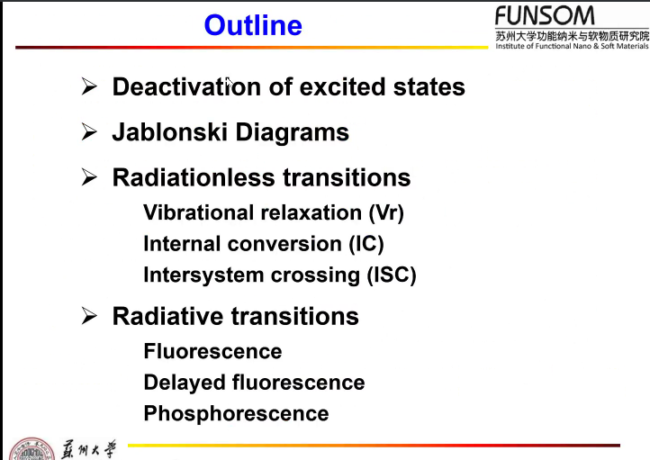

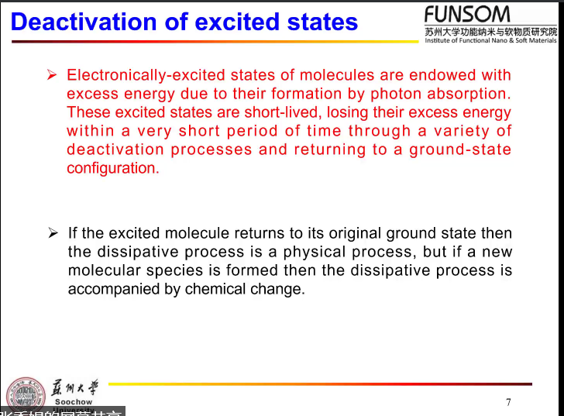

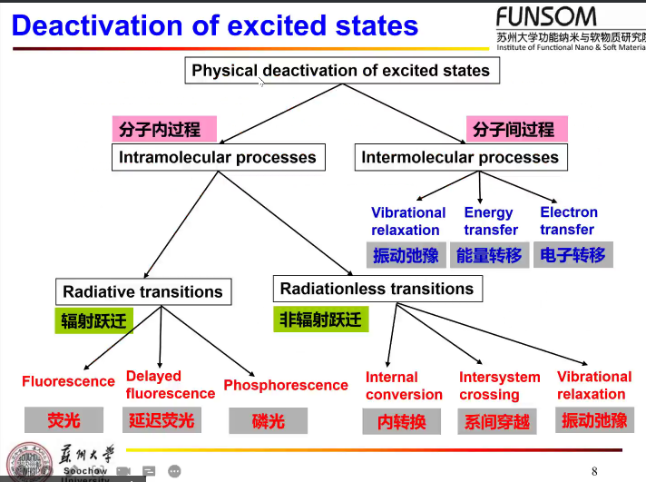

intersystem- 系间- 单线态，三线态

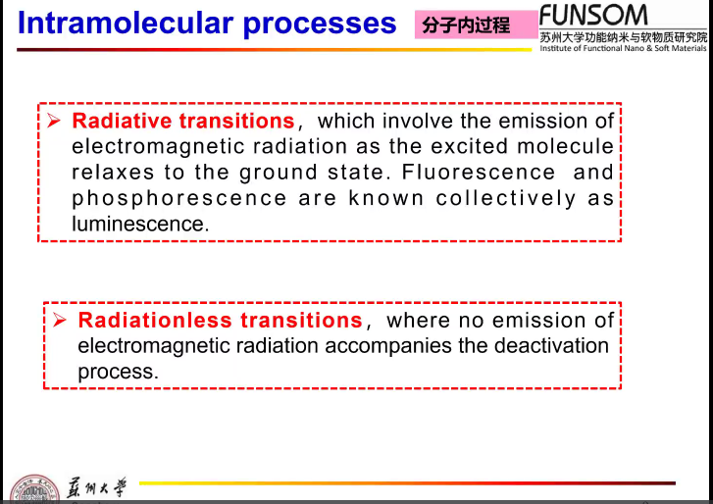

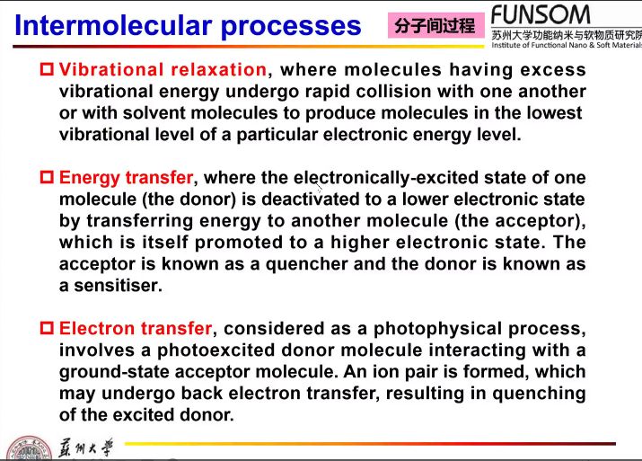

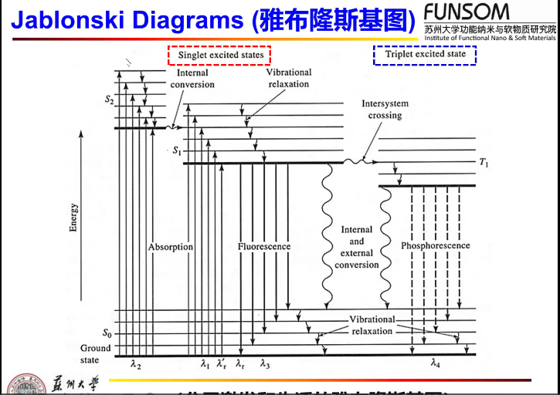

全记住，会画。

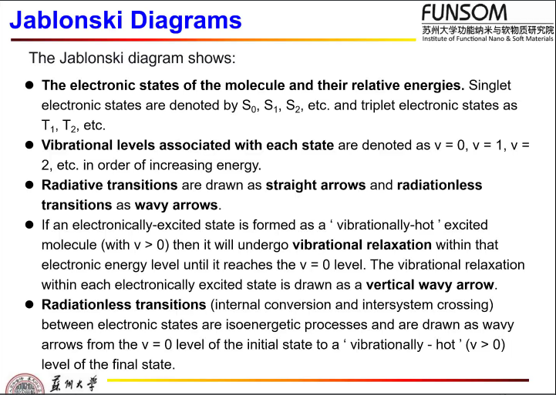

I. non-radiative transition

(i) vibrational relaxation

Collision 碰撞

The transition between a vibrationally-excited state (v>0) and the v = 0 state within a given electronic state when excited molecules collide with other species such as solvent molecules, for example S2(v=3) to S2(v=0)

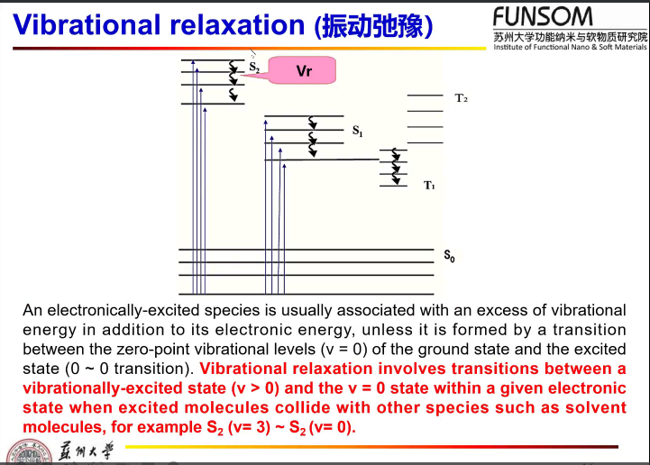

(ii) Internal conversion

Same energy and multiplicity

Internal conversion involves intramolecular radiationless transitions between vibronic states of the same total energy (isoenergetic states 等能量状态) belonging to different electronic state and the same multiplicity. 相同能量的所属于不同电子激发态能级的振动能级。

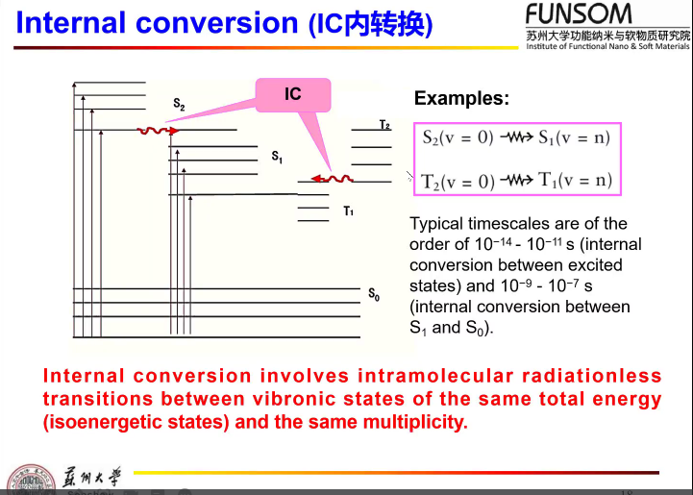

(iii) intersystem crossing

A non-radiative transition between two isoenergetic vibrational levels belonging to electronic states of different multiplicities.

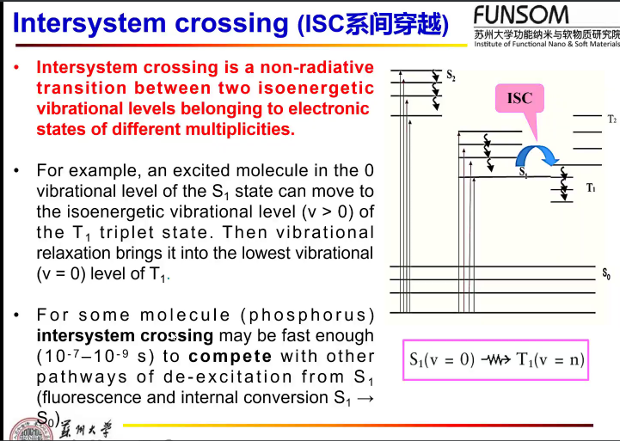

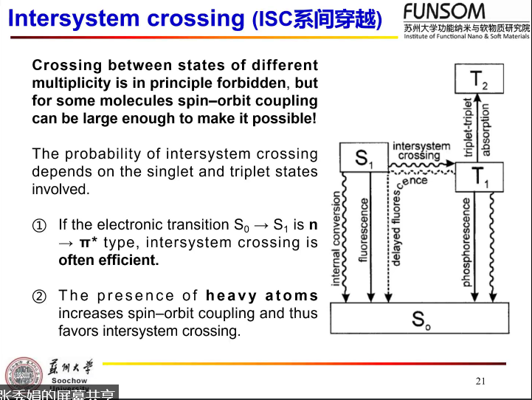

II. radiative transitions

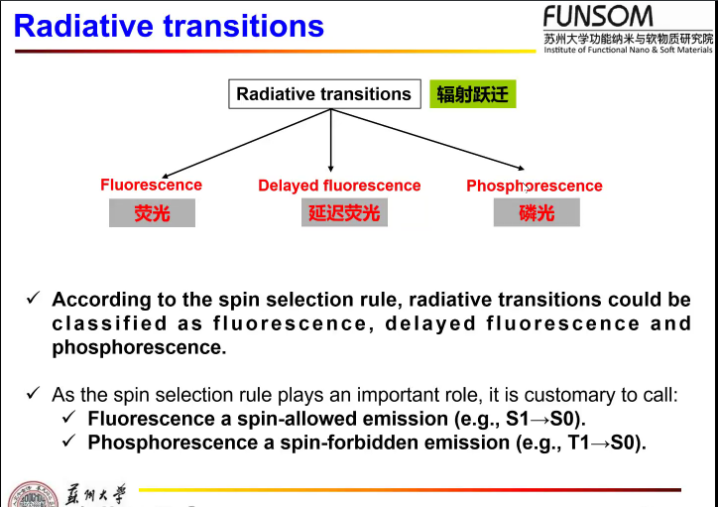

(i) Fluorescence

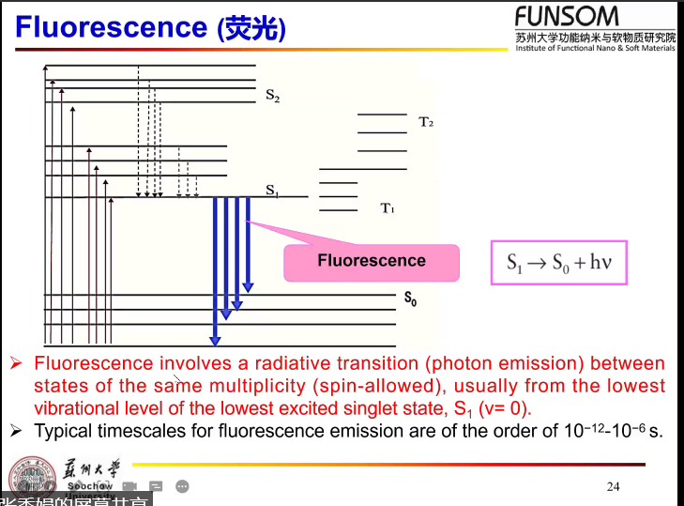

Fluorescence: a radiative transition (photo emission) between states of the same multiplicity (spin-allowed), usually from the lowest vibrational level of the lowest excited singlet state, S1 (v=0) to the ground state, S0 (v=n).

(ii) Phosphorescence

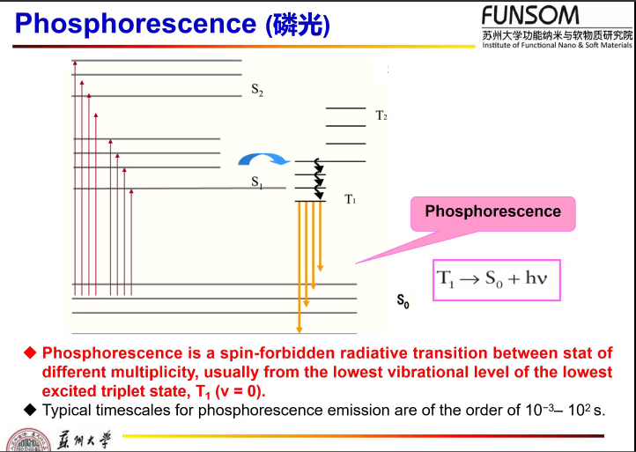

T1(v=0) to ground state S0(v=n)

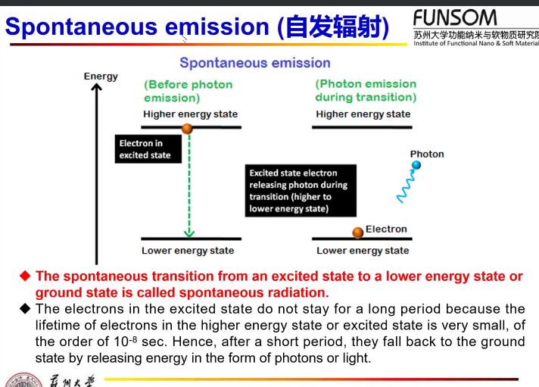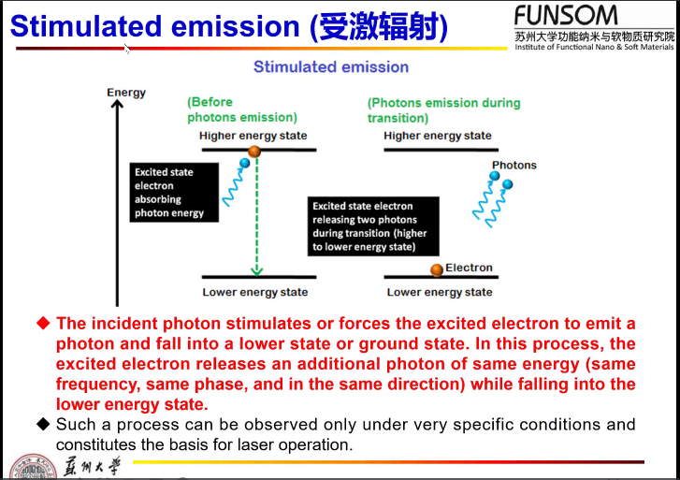

The energy of incident photon must equal to the energy gap between

(iii) Delayed fluorescence

